SEMESTER ONE
Papers written by
Australian Maths Software

YEAR 12
MATHEMATICS METHODS
REVISION 2
Unit 3
2016
Section Two
(Calculator–assumed)
Name: _________________________________

Teacher: ________________________________

TIME ALLOWED FOR THIS SECTION

Reading time before commencing work: 10 minutes
Working time for section: 100 minutes

MATERIAL REQUIRED / RECOMMENDED FOR THIS SECTION

To be provided by the candidate
Standard items: pens, pencils, pencil sharpener, highlighter, eraser, ruler.

Special items: drawing instruments, templates, notes on up to two unfolded sheet of A4 paper, and up to three calculators approved for use in the WACE examinations.

IMPORTANT NOTE TO CANDIDATES

No other items may be taken into the examination room. It is your responsibility to ensure that you do not have any unauthorised notes or other items of a non–personal nature in the examination room. If you have any unauthorised material with you, hand it to the supervisor before reading any further.

To be provided by the supervisor

Question/answer booklet for Section Two.
Formula sheet retained from Section One.
Structure of this examination

 | Number of questions available | Number of questions to be answered | Working time (minutes) | Marks available | Percentage of exam
Section One  Calculator—free | 7 | 7 | 50 | 50 | 35
Section Two  Calculator—assumed | 13 | 13 | 100 | 100 | 65
Total marks |  |  |  | 150 | 100

Instructions to candidates

1. The rules for the conduct of this examination are detailed in the Information Handbook.
Sitting this examination implies that you agree to abide by these rules.

2. Write your answers in the Question/Answer booklet.

3. You must be careful to confine your responses to the specific questions asked and to
follow any instructions that are specific to a particular question.

4. Spare pages are provided at the end of this booklet. If you need to use them, indicate
in the original answer space where the answer is continued i.e. give the page number.

5. Show all your working clearly. Your working should be in sufficient detail to allow your answers to be checked readily and for marks to be awarded for reasoning. Incorrect answers given without supporting reasoning cannot be allocated any marks. For any question or part question worth more than two marks, valid working or justification is required to receive full marks. If you repeat an answer to any question, ensure that you cancel the answer you do not wish to have marked.

6. It is recommended that you do not use pencil, except in diagrams.

7. The Formula Sheet is not to be handed in with your Question/Answer booklet.

8. (8 marks)
A fundraising committee wants to raise as much money as possible on a film evening.
If they charge $25 per person they expect 100 people will attend. From experience
they know that for every $1 they increase the price, 3 people less will attend and for
every $1 they drop the price, they expect 3 more people to attend.

(a) Complete the following table. (2)

Price per entry | Number of people attending | Revenue
$26
$25 | 100 | $2 500
$24

(b) Let x be the increase in price in dollars.
Find an expression in terms of for the expected revenue. (1)
$(25+ x)

(c) Use a calculus method to find the price to charge for the film evening to maximise the revenue. Show all working. (5)

9. (10 marks)
The probability that a new Hardwear tyre will last 18 months is 0.7.
Gerry bought 4 new Hardwear tyres for his car.
(a) What is the probability that over the next 18 months
(i) all four tyres will still be OK? (2)

(ii) at least one tyre will need replacing? (2)

(iii) exactly one tyre will need replacing? (2)

(b) (i) Find the expected number of tyres that need replacing over 18 months. (2)

(ii) Find the variance of the distribution. (2)

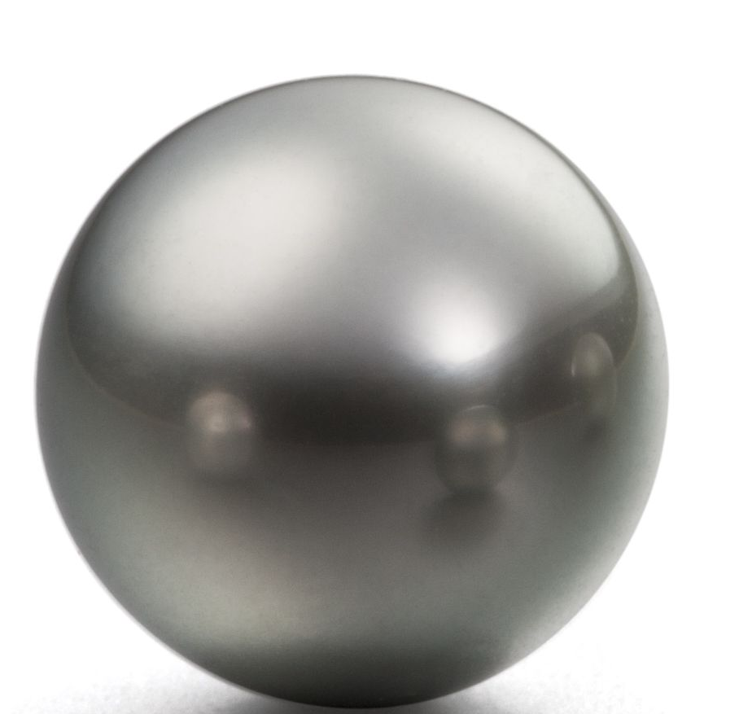
10. (4 marks)
The value of a spherical pearl, assuming the quality is good,
Is proportional to the volume of the pearl.
Eddie estimated the diameter to be 12 mm.
The diameter was actually 11 mm.

Use a calculus method to estimate the error in the estimated volume of the pearl. (4)

11. (6 marks)
The acceleration of a particle is given by 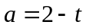
(a) Determine an expression for the velocity and displacement given that at
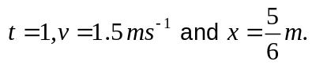 (3)

(b) Determine the displacementwhen the particle first changes direction for 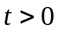. (3)

12. (7 marks)
The definition of a derivative of a functionis defined as
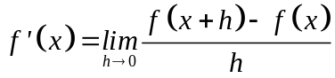 .

(a) Consider 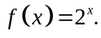
Fill in the gaps indicated below as ***.
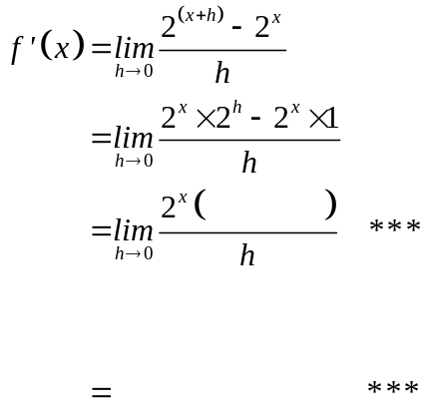 (2)
(2)

Therefore if 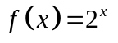
then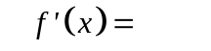 *** (1)

(b) Given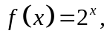 find 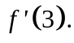 (2)

13. (11 marks)
(a) A body moves according to the law 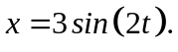
(i) Findwhen 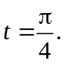 (1)

(ii) Find the expressions for velocity 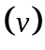and acceleration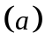. (2)

(iii) Show that 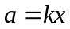 whereis a constant. (1)

(b) Given the functions 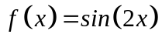and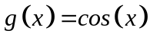, find the smallest
positive where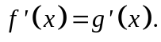 (3)

(c) Some of the following functions have the same derivative.
Choose pairs of functions that have the same derivatives and explain why this is
so.

(i) 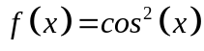
(ii) 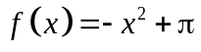
(iii) 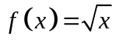
(iv) 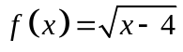
(v) 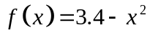
(vi) 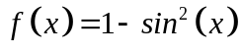 (4)

14. (5 marks)
(a) Given 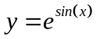
(ii) find an expression (1)

(ii) hence evaluate 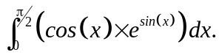 (2)

(b) Use your calculator to evaluate 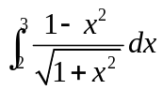 correct to two decimal places. (2)

15. (8 marks)
The population in China in 1965 was estimated to be 715.2 million people.
In 1979 this had increased to 969 million people.

(a) Had this rate of growth continued, what is the expected population in 2016? (3)

With the introduction of the one child policy in 1979, the population was thought to be
increasing at a slower rate.
In 2015 China’s population was 1 401.6 million people.
(b) What was the annual rate of growth since 1979? (3)

(c) What reduction in population did the one child policy result in by 2016? (2)
16. (11 marks)
(a) Consider the graph below
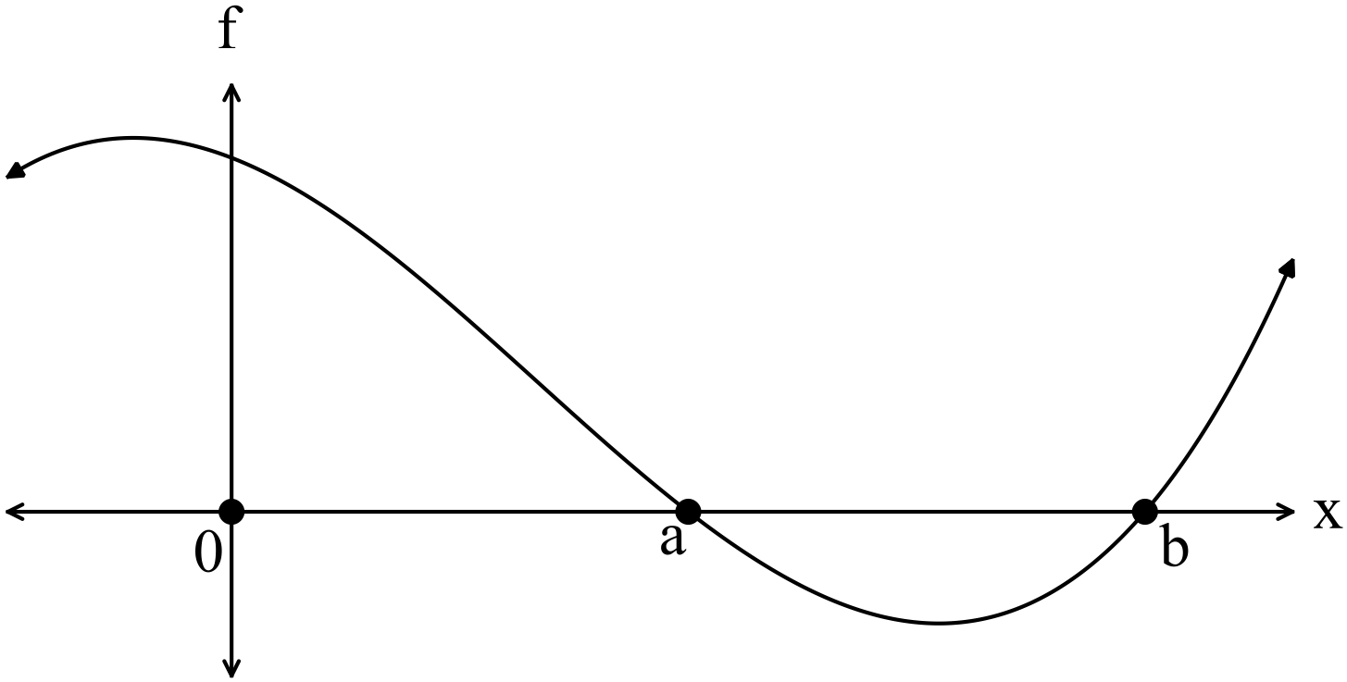
Given 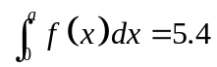 and 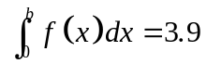
(i) find 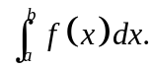 (2)

(ii) find the area bounded by the function and theaxis on the interval 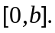
(2)

(b) The function is graphed below.

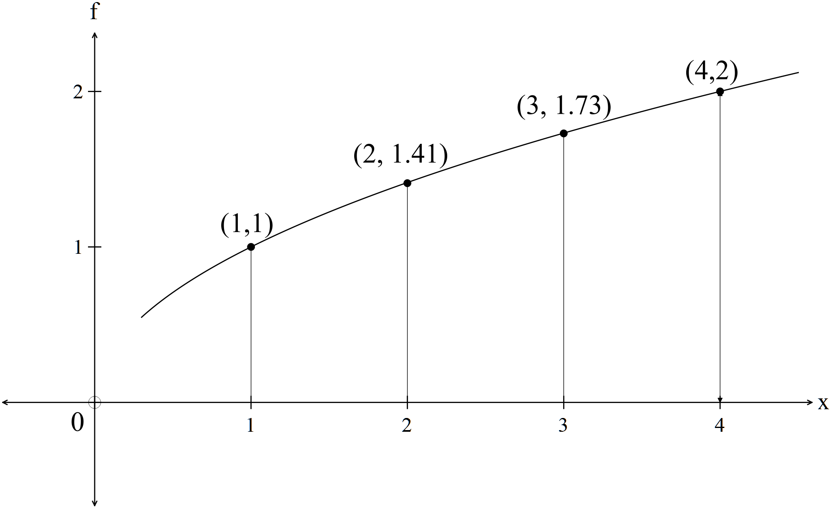

(i) Using rectangles from above and from below, find an estimate for the area
between the function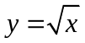,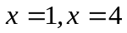 and theaxis .
Use 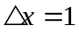as the width of the interval. (5)

(ii) Use integration to evaluate the exact area estimated in (i). (2)

17. (5 marks)
Consider the following table.

 | 1 | 2 | 3 | 4 | 5
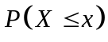 | 0.1 | 0.4 | 0.7 | 0.9 | 1

(a) Complete the probabilities in the table below (2)
 | 1 | 2 | 3 | 4 | 5
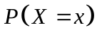 | 0.1

(b) Find 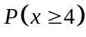 (1)

(c) Find 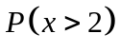 (2)
18. (8 marks)
A spinner is labelled 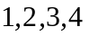and a die is rolled. The number on the spinner and the
upper face of the die are added.
The possible outcomes are shown in the table below.

 |  |  |  | Die
 | Scores | 1 | 2 | 3 | 4 | 5 | 6
 | 1 | 2 | 3 | 4 | 5 | 6 | 7
Spinner | 2 | 3 | 4 | 5 | 6 | 7 | 8
 | 3 | 4 | 5 | 6 | 7 | 8 | 9
 | 4 | 5 | 6 | 7 | 8 | 9 | 10

(a) Complete the probability density table below for the scores. (3)
x | 2 | 3 | 4 | 5 | 6 | 7 | 8 | 9 | 10
P(X = x)

(b) Find the probability that the score is even. (2)

(c) Find the probability of a score less than 6. (2)

(d) Find 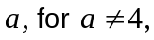 such that 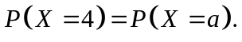 (1)

19. (12 marks)
(a) Determine if the data in the following table represents a discrete random
variable. Give your reasons. (2)
 | 3 | 4 | 5 | 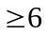
 | 0.1 | 0.3 | 0.4 | 0.2

(b) (i) Complete the following table for a discrete random variable 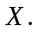 (2)
 | 1 | 2 | 3 | 4
 | 0.5 | 0.25 | 0.125

Determine
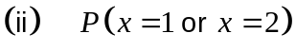 (1)

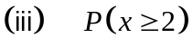 (1)

(iv) the expected value and the standard deviation of (4)
(c) A new discrete probability distribution is formed using the transformation
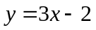on the data in the table in (b).
Write down the expected value and standard deviation of 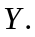 (2)

20. (5 marks)
The probability of a scratchy winning a prize is about 15%.
Paul wants to know how many scratchies he should buy for his wife so that she has at
least a 90% chance of having two winning tickets.

Write down an equation that needs to be solved to give Paul his answer. (5)
(You do not have to solve the equation.)

END OF SECTION TWO

